Exercise 1 - Data Storage
Data Storage, Sekolah Engineering, Pacmann

Outline
Task Description 2
Dataset Overview 2
Instructions 4
Step #1 - Requirements Gathering (10 points) 4
Step #2 - Designing Data Warehouse Model (80 points) 5
Step #3 - Create Report(10 points) 7

Task Description
Olist, a major online marketplace in Brazil, connects small businesses to customers through various sales channels. As the business grows, Olist faces the challenge of managing and analyzing large volumes of transactional data generated by multiple sellers and diverse customer interactions. To maintain its competitive edge and improve decision-making processes, Olist has identified several key areas where in-depth data analysis is crucial:
- Customer Satisfaction and Review Analysis
- Customer Sentiment Clustering
- Sales Prediction:
- Delivery Performance Optimization:
To achieve these objectives, Olist needs a data infrastructure that allows them to store, manage, and analyze large volumes of diverse data efficiently. Olist requires a dedicated data warehouse to support advanced analytics and data-driven decision-making. As a Data Engineer, your primary task is to design a dimensional model to support Olist's data analysis needs.
Your Main Task:
- Requirements Gathering
You will be required to understand the problem given by stakeholders
- Designing Data Warehouse Model
Based on the results of Requirements Gathering, you will create a dimensional model of the Data Warehouse, including:
- Dimensional Tables
- Fact Tables
  - Use at least 2 types of fact tables

Dataset Overview
This dataset was generously provided by Olist, the largest department store in Brazilian marketplaces. Olist connects small businesses from all over Brazil to channels without hassle and with a single contract. Those merchants are able to sell their products through the Olist Store and ship them directly to the customers using Olist logistics partners. After a customer purchases the product from Olist Store a seller gets notified to fulfill that order. Once the customer receives the product, or the estimated delivery date is due, the customer gets a satisfaction survey by email where he can give a note for the purchase experience and write down some comments. [src: link]
Attention:
- An order might have multiple items.
- Each item might be fulfilled by a distinct seller.
- When a customer makes a purchase, the payment may not always be completed in a single payment transaction.
- Personal data is anonymized.
- Order Funnel:
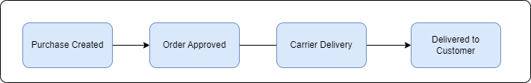

ERD
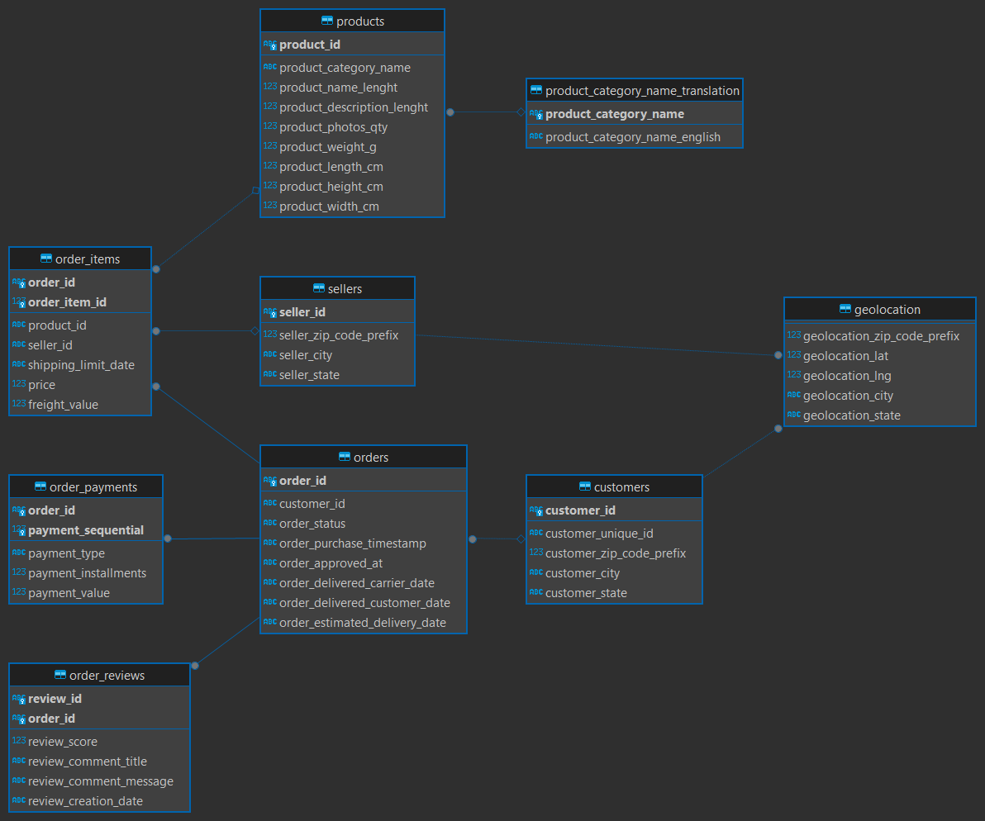

Access:
Link Repository: link
Import Data:
- Create File .env
# Source
SRC_POSTGRES_DB=olist-src
SRC_POSTGRES_HOST=localhost
SRC_POSTGRES_USER=postgres
SRC_POSTGRES_PASSWORD=[YOUR PASSWORD]
SRC_POSTGRES_PORT=[YOUR PORT]

# DWH
DWH_POSTGRES_DB=olist-dwh
DWH_POSTGRES_HOST=localhost
DWH_POSTGRES_USER=postgres
DWH_POSTGRES_PASSWORD=[YOUR PASSWORD]
DWH_POSTGRES_PORT=[YOUR PORT]

- Execute this command

docker compose up -d


Instructions

Step #1 - Requirements Gathering (10 points)
In this step, your task is to simulate a requirement-gathering session with stakeholders for designing a Data Warehouse for the Olist dataset. You need to create a list of at least five questions you would ask stakeholders to understand their needs and requirements. After each question, provide a possible answer that a stakeholder might give based on the dataset and business needs. The objective is to identify key elements needed to design the Data Warehouse.
- Create Questions: Develop at least five questions that you would ask stakeholders to gather requirements for the Data Warehouse.
- Provide Stakeholder Answers: Write a possible answer for each question based on the context of Olist's business and dataset.

Step #2 - Designing Data Warehouse Model (80 points)
In this step, your task is to design a dimensional model for the Data Warehouse based on the requirements identified in Step #1. You will define key elements such as business processes, grain, dimensions, facts, and relationships between different components. The goal is to create a well-structured model that supports the analysis needs of the stakeholders.

- Design Dimensional Model Process
  - Select Business Process (10 points)
Identify and select the core business processes that the Data Warehouse will support.
Expected Output: A clear statement on which business processes are selected and why they are important for the Data Warehouse.
  - Declare Grain (10 points)
Define the grain for each fact table, specifying the level of detail for each record in the fact table. The grain should be aligned with the business requirements gathered in Step #1.
Expected Output: A definition of the grain for your business process, such as "one row per order item per day"
  - Identify The dimension (20 points)
Identify the dimensions that are required for each business process
Expected Output: A list of dimensions with a brief description of each, including attribute and key behavior
  - Identify the fact
Determine the fact tables required for the Data Warehouse based on the business processes selected. Decide on the type of fact tables to use:
- Using a Single Type of Fact Table (10 points):
If you choose to use only one type of fact table, such as a Transaction Fact Table or an Accumulating Snapshot Fact Table, ensure it captures all relevant measures for the business processes identified.
Expected Output: A well-defined fact table with its grain, measures, and dimensions

- Using More Than One Type of Fact Table (20 points):
If you choose to use more than one type of fact table (e.g., Transaction Fact Table along with an Accumulating Snapshot Fact Table or a Periodic Snapshot Fact Table), ensure each fact table supports different analytical needs or levels of granularity.
Expected Output: A set of fact tables with their respective grains, measures, and dimensions.
  - Full ERD (10 points)
Create a full ERD to visualize the relationships between the fact tables and dimension tables. The ERD should clearly show the foreign key relationships, cardinality, and any other relevant details.
Expected Output: A comprehensive ERD that includes all fact and dimension tables and relationships.
  - Bus Matrix (10 points)
If your model includes more than one fact table, create a bus matrix to outline the relationships between the fact tables and shared dimensions. The bus matrix is a helpful tool to ensure consistency and conformity across the Data Warehouse. Refer to "The Data Warehouse Toolkit, 3rd Edition" for guidance on creating the bus matrix.

Step #3 - Create Report(10 points)
In this step, you are required to write a comprehensive report in the form of a Medium article. The report should summarize the process of designing the Data Warehouse for Olist
Points you can write down:
- Introduction of the project
- Requirements Gathering Process
- Designing the Data Warehouse Model
Detail the dimensional modeling process, including:
  - The selected business processes and their relevance to the company's goals.
  - The grain declaration for the fact tables and the reasons behind choosing that level of granularity.
  - A breakdown of the identified dimensions and their attributes
  - An explanation of the fact tables used, their types (transaction, periodic snapshot, accumulating snapshot).
  - Final ERD and Bus Matrix

